PENGIRAN ANAK PUTERI RASHIDAH SA’ADATUL BOLKIAH
INSTITUTE OF HEALTH SCIENCES

After-Hours Access Request Form (For Students ONLY)

This form must be completed and approved before access to faculty buildings or facilities is granted outside regular working hours. (Through online and official email ONLY. Do Not Print)

Section1: Applicant Details
Full Name:
Student ID No.:
Program:
Phone Number:
Email Address:

Section 2: Emergency Contact (At least 2 persons)
1. | Full Name:
1. | Phone Number :
1. | Relation:
2. | Full Name:
2. | Phone Number:
2. | Relation:

Section 3: Access Details
Purpose of Access:
Specific Area(s) to Access:
Access Dates: | From: | To:
Access Time: | From: | To:
Reminder:
- Laboratory work is permitted until 7:00 PM ONLY.
- Should you require to stay after 7:00 PM, You must seek approval from your supervisor or Program Leader.
- All other facilities must close by 10:00 PM at the latest.

Section 4: Safety & Responsibility
I acknowledge and agree to, 1. Comply with all safety and security protocols.
2. Take full responsibility for my safety and the facility.
3. Ensure no unauthorized persons in restricted areas.
4. Immediately report any incidents or concerns.

Signature of Applicant: | Date:

Section 5: Approval (Supervisor / Program Leader)
Signature:

Name: | Date:

NOTE: Approver (Supervisor/Program Leader) is to email the approved form to the student and, c.c to the following email addresses;

- office.campus@ubd.edu.bn
- she.ihs@ubd.edu.bn
- office.ihs@ubd.edu.bn

Section 6: Instructions to Student (After-Hours Access to PAPRSB IHS Facilities):
Once your request has been approved, please follow the instructions below:
- Download and Save in your hand phone the Approved Form:
An approved after-hours request form must be saved and readily available at all times. This document serves as verification and is required for entry into PAPRSB facilities.
- Notify Zone C Security on Entry and Exit:
You MUST notify Security Officer on Duty every time you Enter and Exit the premises. Please provide softcopy of the approved After-Hours Access Request Form.
- Use the Correct Notification Format:
Please use the “WhatsApp Notification Template” provided below for notifying or contacting UBD Zone C Security. Notification is through a WhatsApp message to 888 9119 (UBD Zone C Security Post). Failure to notify security may result in denial of access and poses potential safety and security risks.
- Requesting Assistance:
If you require assistance—such as Unlocking or Locking the doors, or in the event of a security threat or emergency—please call 888 9119 or 816 9009 directly.

WhatsApp Notification Template to UBD ZONE C Security (After Hours Access Reporting)

(FOR STUDENT)

Student Full Name:
Student ID No:
Program:
Location (Specify):
Purpose:
Date:
Time In:
Time Out:
Approved by: [Supervisor’s or PL’s Full Name]
Approver Contact No:

***UBD Security (Zone C) Contact Number: 888 9119

WhatsApp Notification Template to UBD ZONE C Security (After Hours Access Reporting)

(FOR STAFF)

Full Name:
Post:
Contact No:
Location (Specify):
Purpose:
Date:
Time In:
Time Out:

***UBD Security (Zone C) Contact Number: 888 9119

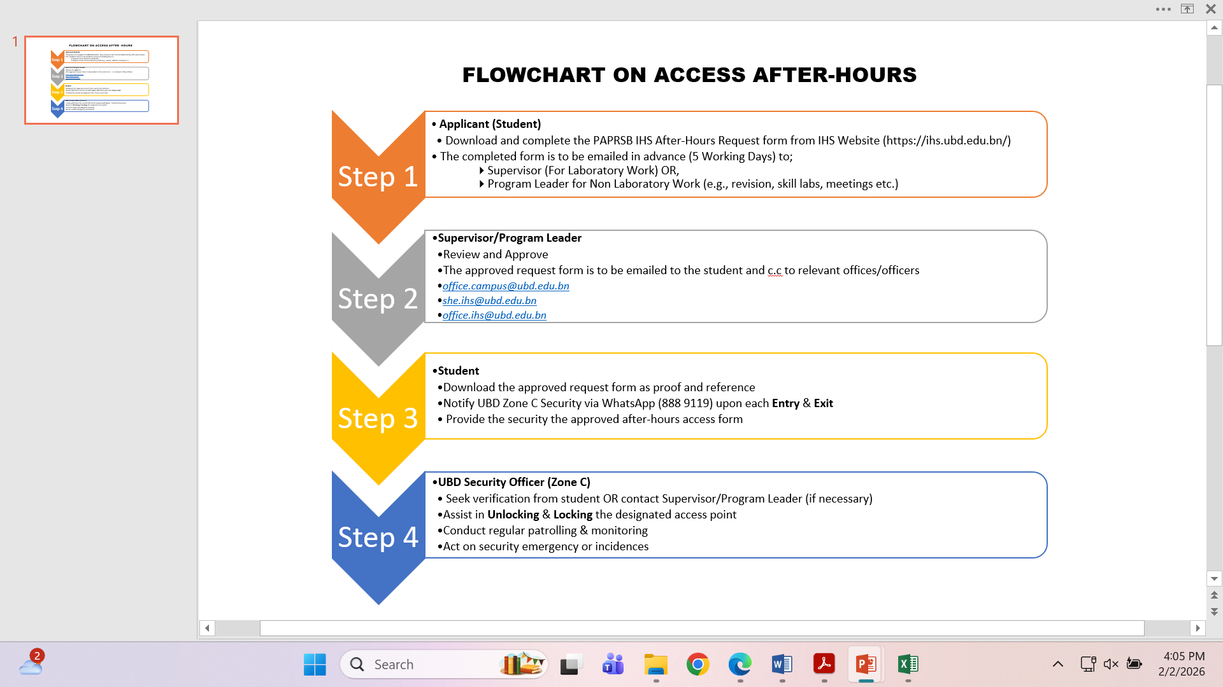
NOTE: All individuals including Officers, Lecturers or Staff intend to stay beyond 4.30 PM on weekdays OR during weekends / public holidays are also required to notify the security via WhatsApp. The UBD ZONE C Security contact number is 888 9119

